

**Tribhuvan University**

**Faculty of Humanities and Social Science**

**Gamified Learning Progress Tracker**

**A PROJECT PROPOSAL**

**Submitted to**

**Department of Computer Application**

**Nepal Mega College**

**In partial fulfillment of the requirements for the Bachelors in Computer Application**

**Submitted by**

Bibek Kapali (6-2-266-34-2022)

Bijay Koirala (6-2-266-36-2021)

March , 2024

Table of Contents

Table of Contents: i

1. Introduction: 1

2. Problem Statement: 1

3. Objectives: 2

4. Methodology: 2

a. Iterative Waterfall Model: 2

b. Requirement identifications: 3

I. Study of the existing system: 3

II. Requirement Collection: 5

c. Feasibility study: 5

I. Technical Feasibility: 5

II. Operational Feasibility: 6

III. Economic Feasibility: 6

IV. Overall Conclusion: 7

d. High level design of the system: 7

I. System Flow Chart: 7

II. Use Case Diagram 9

III. Data Flow Diagram 10

IV. ER Diagram 12

5. Gantt Chart: 14

6. Expected Outcomes: 15

7. References 17

# 1. Introduction:

Let's imagine a world where learning is more like playing a game than dealing with dull grades. Meet the "Gamified Learning Progress Tracker" – a system that turns your academic journey into an exciting adventure! Instead, think of it as an exciting journey, where you face challenges, unlock skills, and level up as you learn.

Forget boring reports and confusing grades! This tracker will be your personal cheerleader, highlighting your strengths, supporting your weaknesses, and showing you exactly how far you've come. Imagine seeing your progress reflected in colorful graphs and charts, feeling the motivation surge with each earned badge, and celebrating milestones with virtual fireworks!

But it's not just about fun and games. This system is powered by real data, giving you and your teachers valuable insights into your learning journey. Think of it as a treasure map revealing your hidden potential, pinpointing areas where you shine, and guiding you towards becoming the ultimate learner.

Ready for the journey of making something awesome together? Join the Gamified Learning Progress Tracker and get ready to unlock a world of learning, excitement, and personalized growth!

Overall, this is just like old progress tracker but with a new interactive ui/ux and badge system.

# 2. Problem Statement:

Have you ever felt like report cards only tell half the story? They might show your grades, but what about the hours you spent studying, the challenges you overcame, or the skills you mastered? Traditional grading often paints a one-dimensional picture, neglecting the diverse learning styles, strengths, and needs of individual students. This can be discouraging, especially for those who learn differently or struggle to fit into a uniform pattern. It can also leave both students and teachers in the dark about the specific areas where improvement is needed.

Imagine a student who excels in creativity but struggles with memorization. Their grades might not reflect their true potential, leaving them feeling discouraged and their creativity untapped. Or, a teacher might see a dip in class performance but lack the insights to pinpoint the exact skill causing the difficulty. This is where the “Gamified Learning Progress Tracker” enters. By focusing on personalized progress and skill development with better user interface, it aims to bridge this gap and empower both students and teachers.

# 3. Objectives:

Get ready to embark on a personalized learning journey with exciting features aimed to benefit students, teachers, and parents/guardians alike! Each objective serves as a stepping stone, guiding all towards building a system that empowers everyone involved:

* To show students their learning progress in fun charts and graphs.
* To help teachers understand each student's strengths and needs.
* To keep parents informed about their child's learning journey.
* To make learning fun with points and badges, turning studying into an epic adventure.

In a nutshell, our goals set the stage for an awesome learning adventure! For students, it's all about seeing progress, unlocking skills, and getting motivated with fun gamification. Teachers get insights to personalize support and unlock each student's potential. Parents and guardians easily track their child's journey, becoming informed cheerleaders. These objectives create a cool, personalized, and fun learning space for everyone. Ready for an epic educational journey? Buckle up for the ride!

# 4. Methodology:

The methodology is a proper study or analysis of all the methods used in the research. Methodology is a project recipe – it guides us, makes sure we have everything we need, and ensures we cook up something amazing in the end. It is like having a set of instructions that shows exactly how achieve the project’s destination. The iterative waterfall methodology of SDLC is one such plan. It breaks down the project into stages, with each stage building on the previous one. By following this methodology, one can systematically work through the project, ensuring that each step is completed before moving on to the next. It’s a reliable way to ensure that the project reaches its destination successfully.

## a. Iterative Waterfall Model:

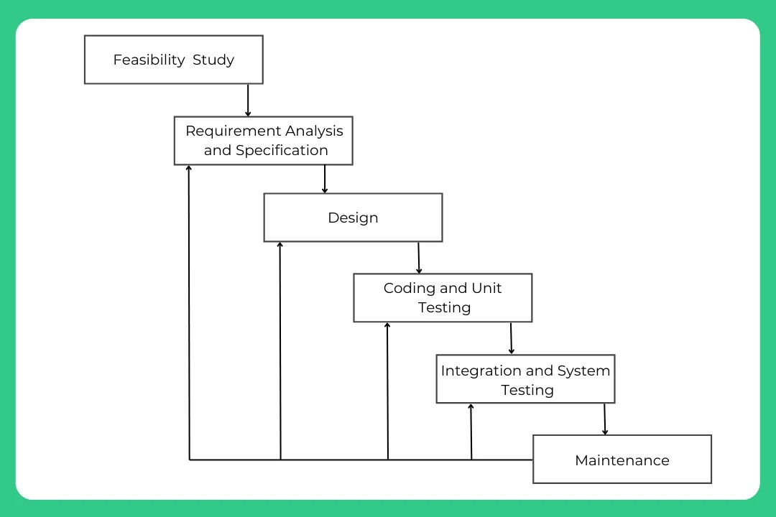For a straightforward process, the iterative waterfall methodology will be followed for effective project development. The system will progress through phases one after another, but iteratively.

**Figure 1: Iterative Waterfall Methodology**

## b. Requirement identifications:

Requirement identification is like figuring out exactly what we need for our project. It is like making a checklist before a journey. First, we check what's in our backpack (study of the existing system). Then, we ask everyone involved what we will need to bring (requirement collection). It's all about understanding what we have and making a list of what we need for a successful adventure.

### I. Study of the existing system:

Examining existing Student Management System [2], Student Progress Tracker [3] also known as light-weight system analysis is like checking out what others have already built-in same field. We look at their features, strengths, and weaknesses to learn from them and avoid repeating mistakes. It's like standing on the shoulders of giants to see further and build something even better. Here are a few things done in this study:

i. Reviewing Documentations:

Close examination of the documents such as proposals [1], project reports [4], and diagrams related to the existing system [5] is undertaken. It's like reading through a book to understand the story and details.

##### ii. Reading Articles:

Diving into articles about the existing Student Management System [2] is similar to exploring chapters of a book to gather additional insights, data, or expert opinions.

##### iii. Technology Assessment:

The technologies used in the existing Student Management System [6], Proposal [1] are evaluated. Imagine it like inspecting the tools in a workshop to make sure they're up to the task.

##### iv. Expert Consultation:

Seeking advice from teachers and friends who are knowledgeable in the field is similar to receiving insights from experienced guides on journey.

##### v. Observation:

Paying close attention to how the existing system naturally operates; Online Shopping System Report[5], Student Management System Project Report [3], Student Progress Tracker [2] is essential. Observations can reveal details that might not be obvious in documents, giving us valuable insights into the system's day-to-day workings.

Here the key question is- what all problems exist in the existing system? What must be done to solve the problem? The commonly used tools in the system are Data Flow Diagram, interviews, etc.

##### Some drawbacks in existing or older systems include:

* Unfriendly user interface and experience (UI/UX)
* Boring and unappealing interface design
* Sluggish performance and slow response times

### II. Requirement Collection:

It is a process of collecting information required for a proper system. The below mentioned points were followed to collect requirements:

##### i. Gather user feedback through methods like:

* Interviews and discussions with friends and teachers.
* Online articles; Feasibility Study [7], Student Progress Tracker [2] and Student Management System report [4].
* Online group chat (BCA 4th sem mem).

##### ii. Analyzed collected data to identify:

* User needs and desired functionalities.
* Pain points and areas for improvement.
* Prioritize requirements based on importance and feasibility.

## c. Feasibility study:

Feasibility refers to the practicality or possibility of a proposed plan, project, or system being successful and effective. A feasibility study is like checking if an idea makes sense and is do-able before diving into it. It's a thorough examination to ensure that a proposed project is realistic, achievable, and economically viable. It involves examining various aspects, including technical, operational, and economic considerations, to determine whether the proposed is feasible and worth pursuing or not [7].

### I. Technical Feasibility:

Examines whether the proposed project can be successfully implemented from a technological perspective.

With the existing knowledge of HTML, CSS, JavaScript, PHP, and MySQL, a solid foundation is laid for completing this project . So, this project is technically viable.

The essential questions that help in testing the operational feasibility of a system include the following:

* Is the proposed system technically achievable with our current knowledge and skills?
* Does the system integrate smoothly with existing technologies and infrastructure?
* Can the technical requirements be met within the proposed budget and timeframe?
* Are there potential challenges in adopting new technologies for the system?
* Is the development team capable of handling any technical issues that may arise during implementation?

Technology used:

* Front-End (HTML, CSS, JS)
* Backend (PHP, SQL)
* Vs Code – code editor

**Conclusion:** The technology used to build this system is readily available and capable of handling any technical issues that may arise during implementation. This is how this system achieves technical feasibility.

### II. Operational Feasibility:

Operational feasibility evaluates the practicality of implementing the proposed project in terms of day-to-day operations.

The essential questions that help in testing the operational feasibility of a system include the following:

* Will the new system seamlessly fit into our day-to-day operations?
* Is the system user-friendly for both students and teachers?
* Does the implementation require extensive training, especially for non-IT users?
* Can the system be easily maintained, and are there effective data management procedures?
* Will the new system contribute to cost-effective information services for the business?

**Conclusion:** The system is easy to use, doesn't disrupt our work, and is easy to maintain. This is how this system achieves operational feasibility.

### III. Economic Feasibility:

* Will the project bring more benefits than it costs to implement?
* Can we clearly see how the new system will save time, resources, or improve services?
* Is the expected gain from the project worth the investment we're making?
* How does the project contribute to the college's overall financial well-being?
* Have we thought about when we might start seeing returns on our investment, and how long that might take?
* ROI = (Total Costs/Net Benefits​) ×100
* Are the initial costs and ongoing expenses within the allocated budget?
* Will the economic benefits outweigh the costs over the long term?

**Conclusion:** The project makes financial sense because it saves time, save resources within a reasonable cost. It's a good investment for any colleges or for any educational institutions.

### IV. Overall Conclusion:

Based on these technical skills, planned features, and resource management approach, the project seems feasible in all three areas.

## d. High level design of the system:

High-level design is like making a big plan for a system. It's the overall idea of how different parts will work together. Think of it as drawing a map before building something.

Now, a High-Level Design Document is like a detailed map. It has pictures and descriptions of the main parts, how they talk to each other, and what they do. It's got details on how information moves around, what choices of technology are used, how things stay safe, and what happens if something goes wrong. It's basically a guidebook for building and understanding the system.

### I. System Flow Chart:

A flowchart is a graphical representation of a process. It's a diagram that illustrates the workflow required to complete a task or a set of tasks with the help of symbols, lines and shapes [8].

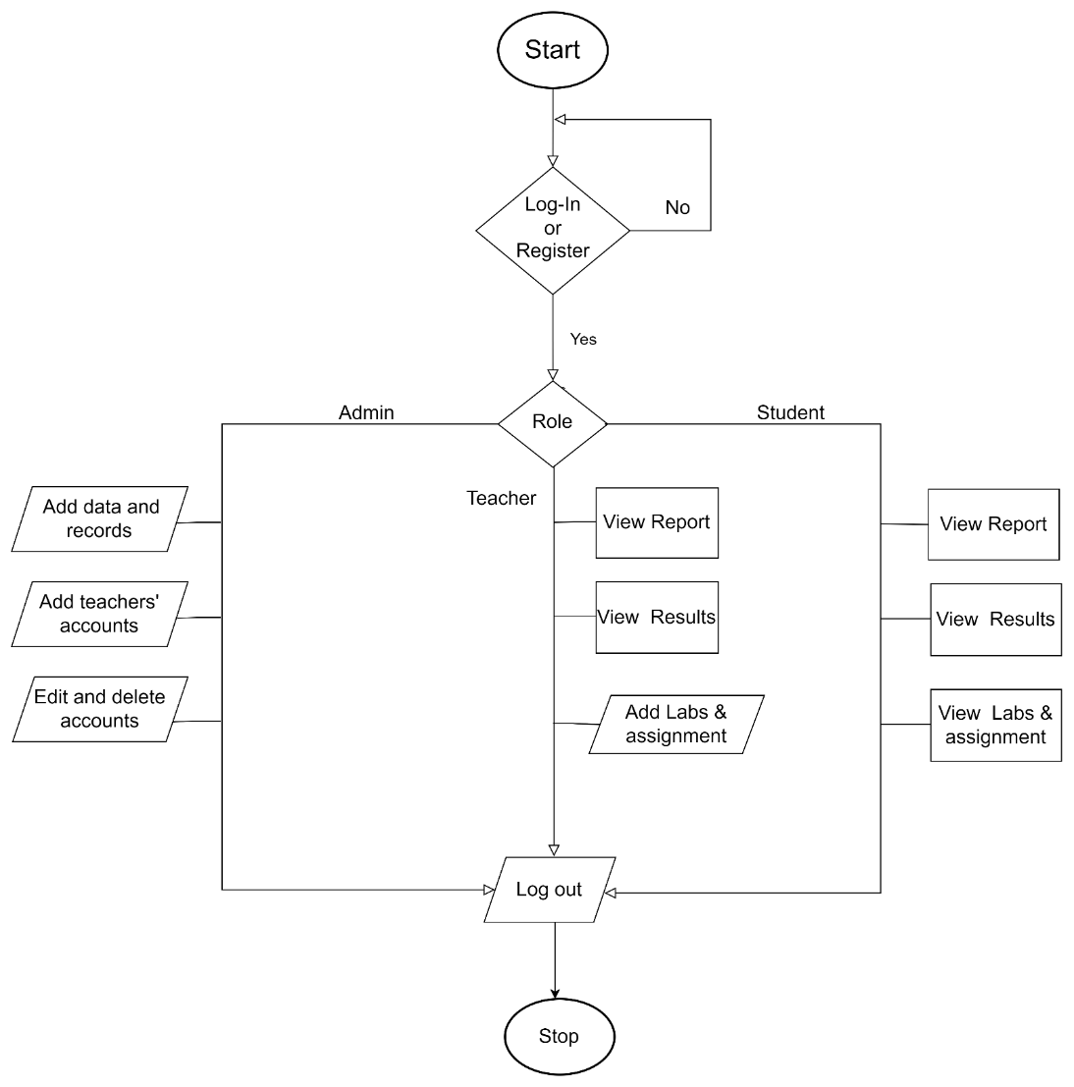

**Figure 2: System Flow Chart**

The project is about a tool for tracking progress in learning that's made fun, like a game. First, you log in or sign up if you're new. Then, it checks if you're an admin, teacher, or student. Admins can add info, manage accounts, and do other big stuff. Teachers can see reports, grades, and give out assignments. Students can see their own reports, grades, and what they need to do for class. When you're done, just log out to finish. That's all !

### II. Use Case Diagram

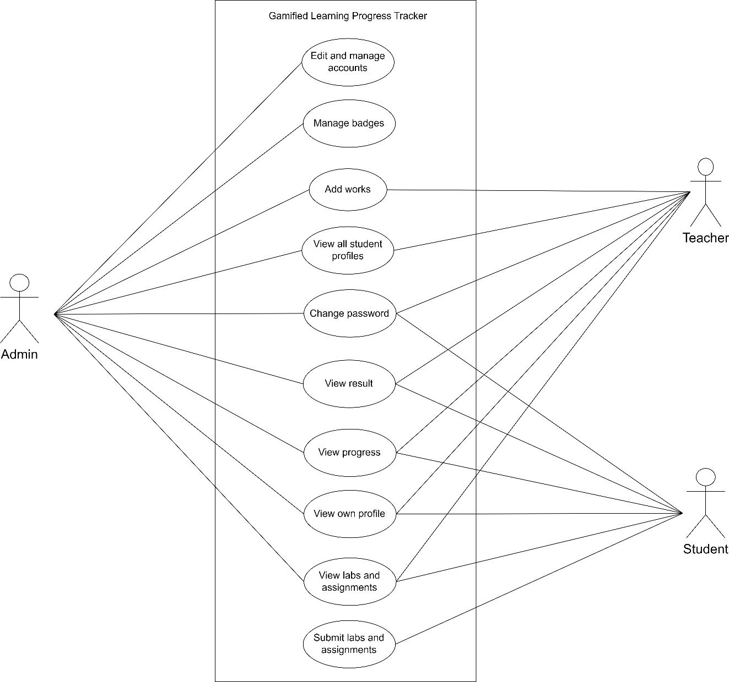A use case diagram is a visual representation of the functional requirements of a system from the perspective of its users. It illustrates the various interactions between users and system.

**Figure 3: Use Case diagram of Gamified Learning Progress Tracker**

Admin is responsible for all the changes in the system whereas teacher will be responsible for the tasks like: adding labs and assignments, and view reports. Here student as an actor can only view the system and can submit the works. This is how we can keep the system secured.

### III. Data Flow Diagram

Data Flow Diagram aka DFD a graphical representation of how data flows through a system. In a DFD, processes are represented by rectangles, data stores by open-ended rectangles, data flows by arrows, and external entities by squares. It helps in understanding the flow of information within a system, including where data comes from, how it's processed, and where it goes. DFDs are commonly used in system analysis and design to visualize and communicate the structure and behavior of a system. DFDs are used to visualize how data moves through a system, aiding in system analysis and design. They facilitate communication by providing a clear representation of data flow to stakeholders. Additionally, DFDs help identify processes and data stores within the system, assisting in understanding its structure and behavior.

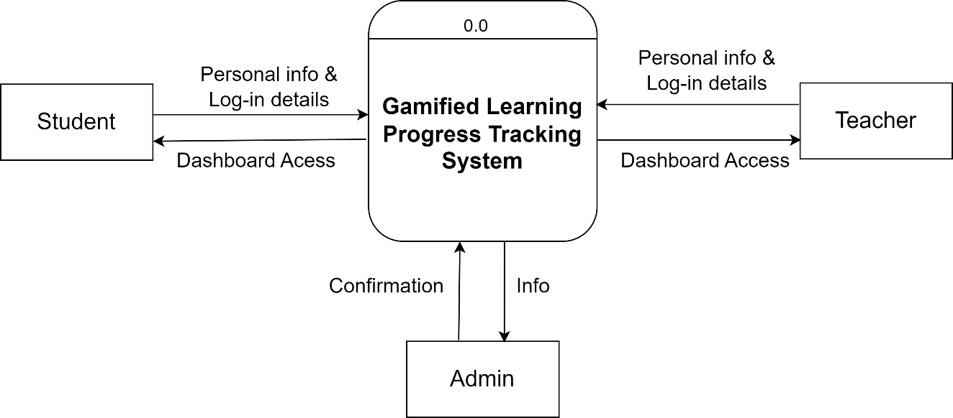

**Figure 4: Context Diagram**

In Level 0 DFD which is also known as context level diagram, we have 2 sources and 2 sinks that is users and admin. Here, users refer to both teachers and students whereas admin is that person who is responsible for the smooth functioning of the whole system.

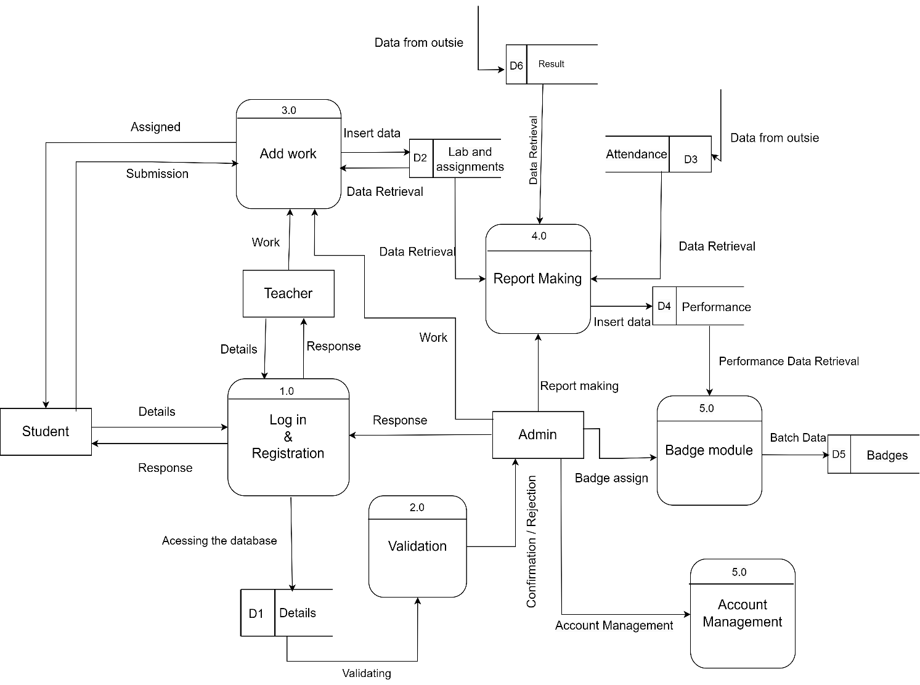

**Figure 5: Level 1 DFD**

Level 1 DFD is more detailed form of level 0 DFD. Here personal details of the users are showed in a database/datastore D0 named as Personal details. When personal details are shared by users, it is processed to a process called login and registration. The data are stored in d0. If admin approve the info, then user will be able to access the system.

The admin and teachers can add the labs and assignments whereas students can only view and submit. From datastores labs and assignments, attendance an overall performance report is made. With the reference of this report admin will assign the badge to the students. Also, admin is able to manage account/id-passwords.

### IV. ER Diagram

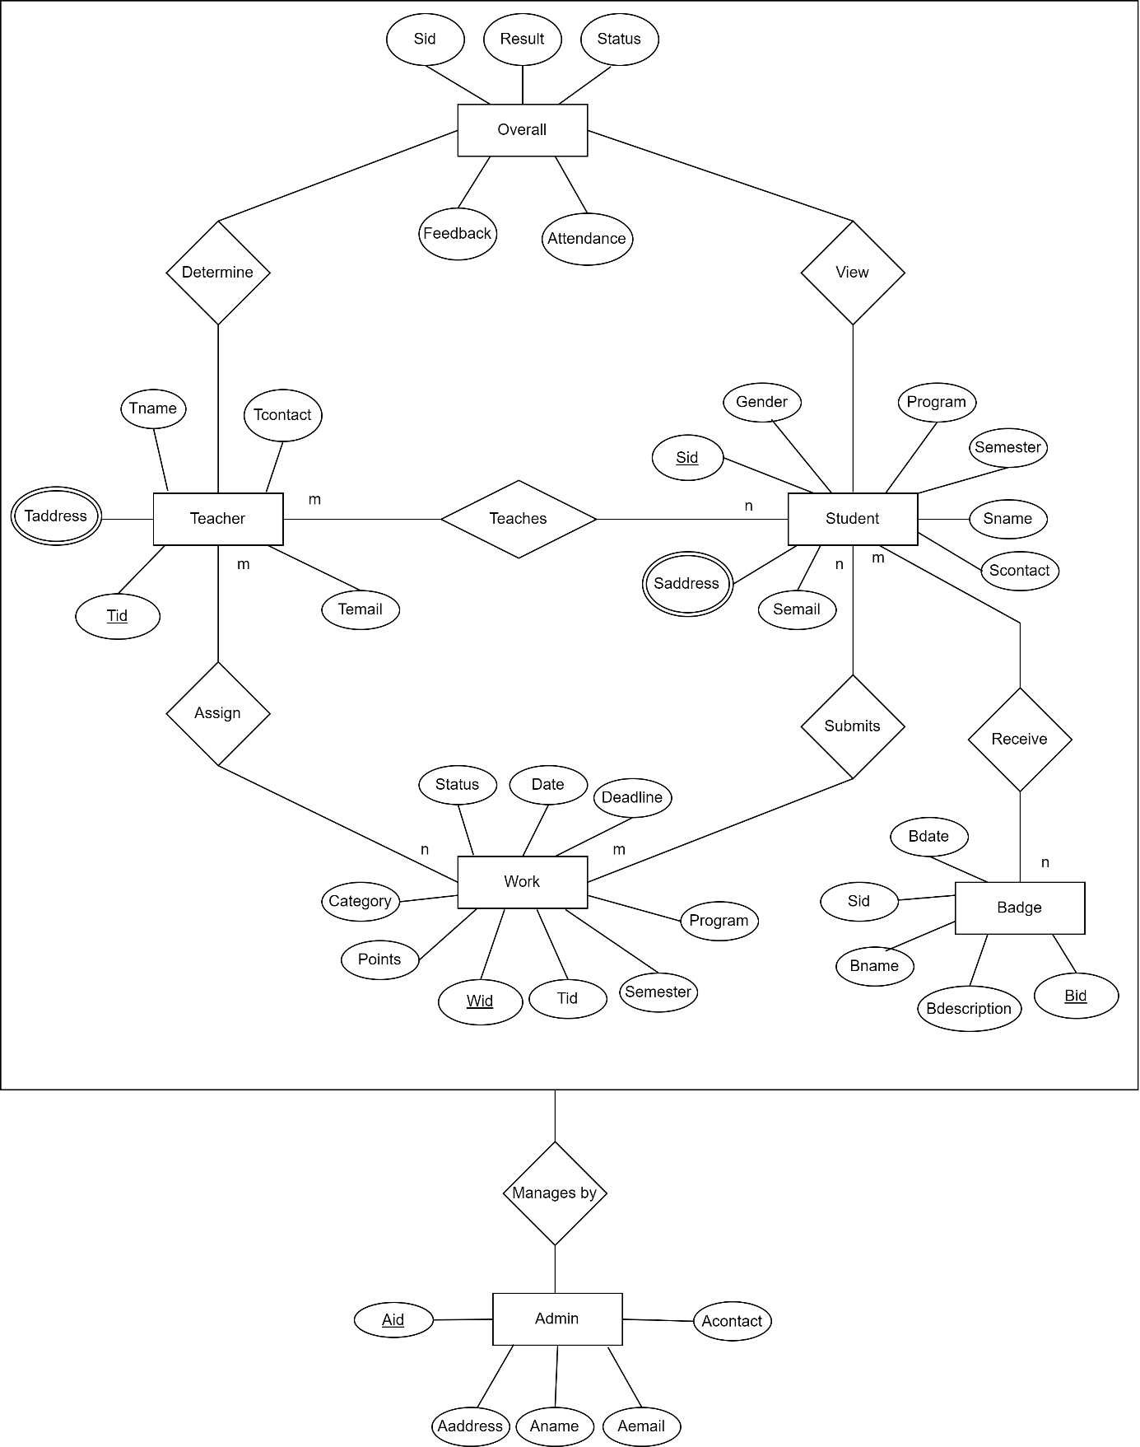An Entity Relationship (ER) Diagram is a type of flowchart that illustrates how “entities” such as people, objects or concepts relate to each other within a system.

**Figure 6: ER Diagram**

In this ER : entities are admin, teacher, student, badge, overall (the whole performance of the students including results, attendance and works’ points), work (labs and assignments) with their specified attributes.

The whole system is taken as a single entity which is being managed by admin which is also known as aggregation.

# 5. Gantt Chart:

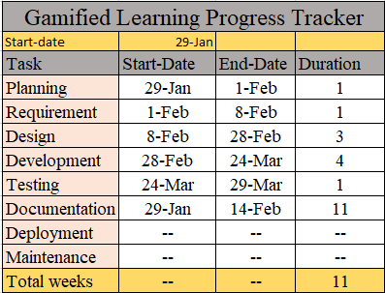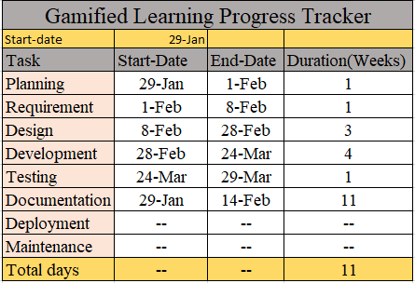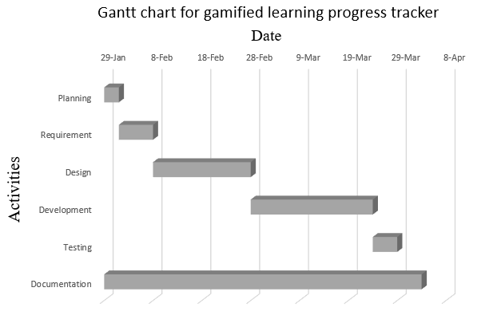A gantt chart is a horizontal bar chart used in project management to visually represent a project plan over time. The purpose of a Gantt chart is to help people see and understand the schedule of a project. It shows all the tasks that need to be done, when they start, and when they finish. This makes it easier to plan and manage the project, as everyone can see what needs to be done and when it needs to be finished. Gantt charts are especially helpful for keeping track of deadlines and making sure that everyone is on the same page about what should happen next.

**Table 1: Activity Table**

**Figure 7: Gantt Chart**

# 6. Expected Outcomes:

The expected outcomes of the project are listed below :

* A functional web application with a clean gaming-type UI.
* A badge system.
* A reliable progress tracking mechanism.

A wireframe is a visual representation or blueprint of a website, application, or software interface. It outlines the basic structure, layout, and functionality of the interface without incorporating design elements like colors, fonts, or images. Here's a simple wireframe for the system including a login page, admin page, dashboard, and profile page :

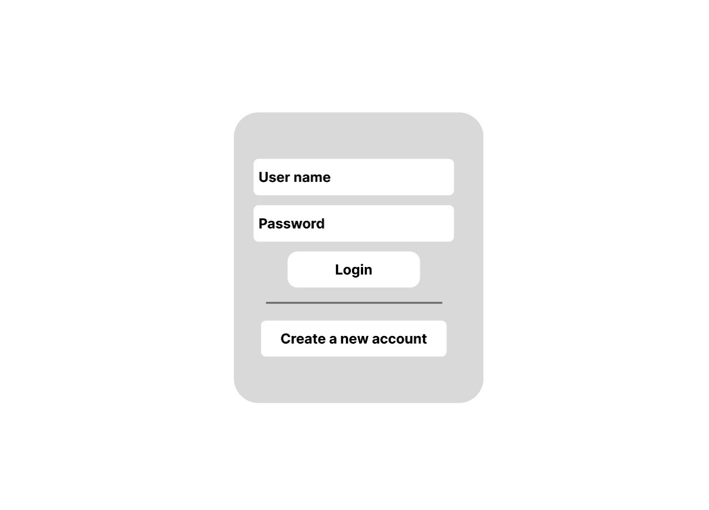

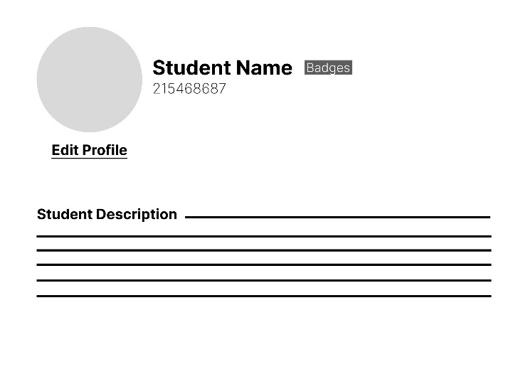

**Figure 8: Login page**

**Figure 9: Profile page**

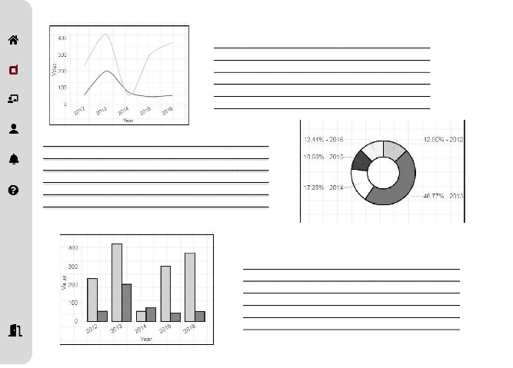

**Figure 10: User Dashboard**

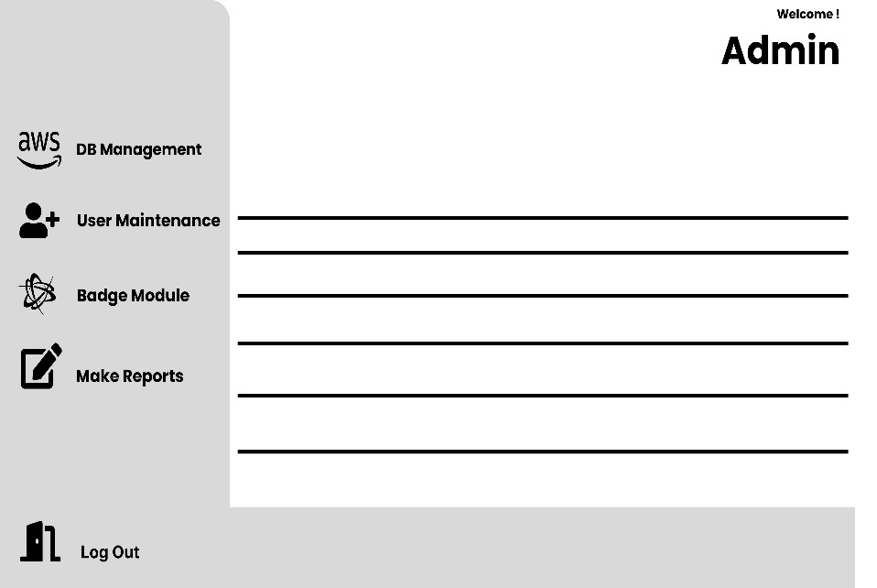

**Figure 11: Admin Dashboard**

In conclusion, these expected outcomes provide a clear vision for success. With a focus on user-centric design, gamified elements, and robust functionality, the project is prepared to deliver an interesting , appealing and impactful web application that meets the needs of its users.

# 7. References

|  |  |
| --- | --- |
| [1 | ] A. SRIVASTAVA, "bca proposal," [Online]. Available: ADITYA SRIVASTAVA. |
| [2 | ] T. Shu, "Research on Student Management System in Colleges," Atlantic Press, Jan 2018.[Online].Available: https://www.researchgate.net/publication/328485788_Research_on_Student_Management_System_in_Colleges. [Accessed 14 feb 2024]. |
| [3 | ] A. Puranik, "Student Progress Tracker," Nov 2022. [Online]. Available: https://ijrpr.com/uploads/V3ISSUE11/IJRPR8055.pdf. [Accessed 14 Feb 2024]. |
| [4 | ] S. H. Shah, "Student Management System Project Report," py lab - Ripah Int'l University,2022. [Online]. Available: https://www.studocu.com/row/document/riphah-international-university/database/student-management-system-project-report/12309562. [Accessed 14 feb 2024]. |
| [5 | ] Svosh, "High-level design document and how it can help us to structure your design artifacts,"Medium,22 Jul 2023. [Online]. Available: https://medium.com/@svosh2/high-level-design-document-and-how-it-can-help-us-to-structure-your-design-artifacts-df9ab5a4f61c. [Accessed 14 feb 2024]. |
| [6 | ] A. A. B. Sajak, "Iterative waterfall model," Jan 2021. [Online]. Available: https://www.researchgate.net/figure/Iterative-Waterfall-Model_fig1_352087214. |
| [7 | ] "1. TECHNICAL FEASIBILITY 2. OPERATIONAL FEASIBILITY 3. ECONOMIC FEASIBILITY," 7 Oct 2011. [Online]. Available: https://osarome.blogspot.com/2011/10/1-technical-feasibility-2-operational.html. [Accessed 14 feb 2024]. |
| [8] | ] M. Academy, "FlowChart for Student Management System," [Online]. Available: https://meeraacademy.com/flowchart-for-student-information-system-project/. [Accessed 14 Feb 2024]. |